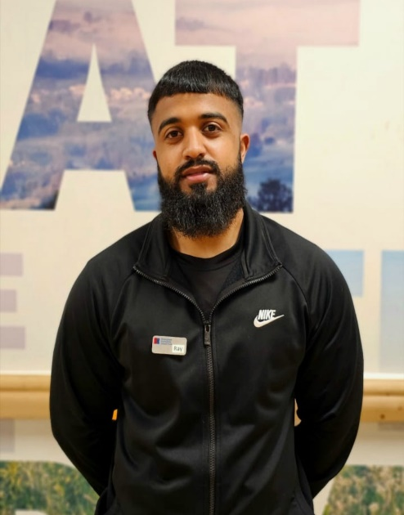

**Gym Instructor**

Level 2

**My specialties**

* General fitness and starting with the basics
* Resistance Training (weights)
* Strength Improvement & Conditioning
* HIIT & Endurance
* Weight Management & Weight Loss
* Lean Muscle Building
* Functional Fitness
* Core stability and so much MORE!



I’m regulated by:

The Chartered Institute for the Management of Sport and Physical Activity (CIMSPA) Member number 35366

**Nutritional Advisor**

**My Qualifications**

**Personal Trainer** Level 3

**About me**

**Hi, I’m ray personal trainer and online coach.**

**I have worked with clients with different goals and do hold proof of testimonials. My passion is to help change peoples lives in the simplest and most realistic way possible.**

* Weight loss/tone up or get fitter for a special event.
* Improve your stability, strength, speed, power, endurance, fitness, and confidence.

I will create you a personalized, unique, and exciting training plan, to keep you motivated and on track with your goals.

I’ll also provide you with dietary advice and simple, but effective, lifestyle changes to ensure you can become the best version of you!

PERSONAL TRAINER PROFILE

Ryhan

Ali

**How do you book me?**

Email: ryhan16786@gmail.com

or ask at reception for more details.